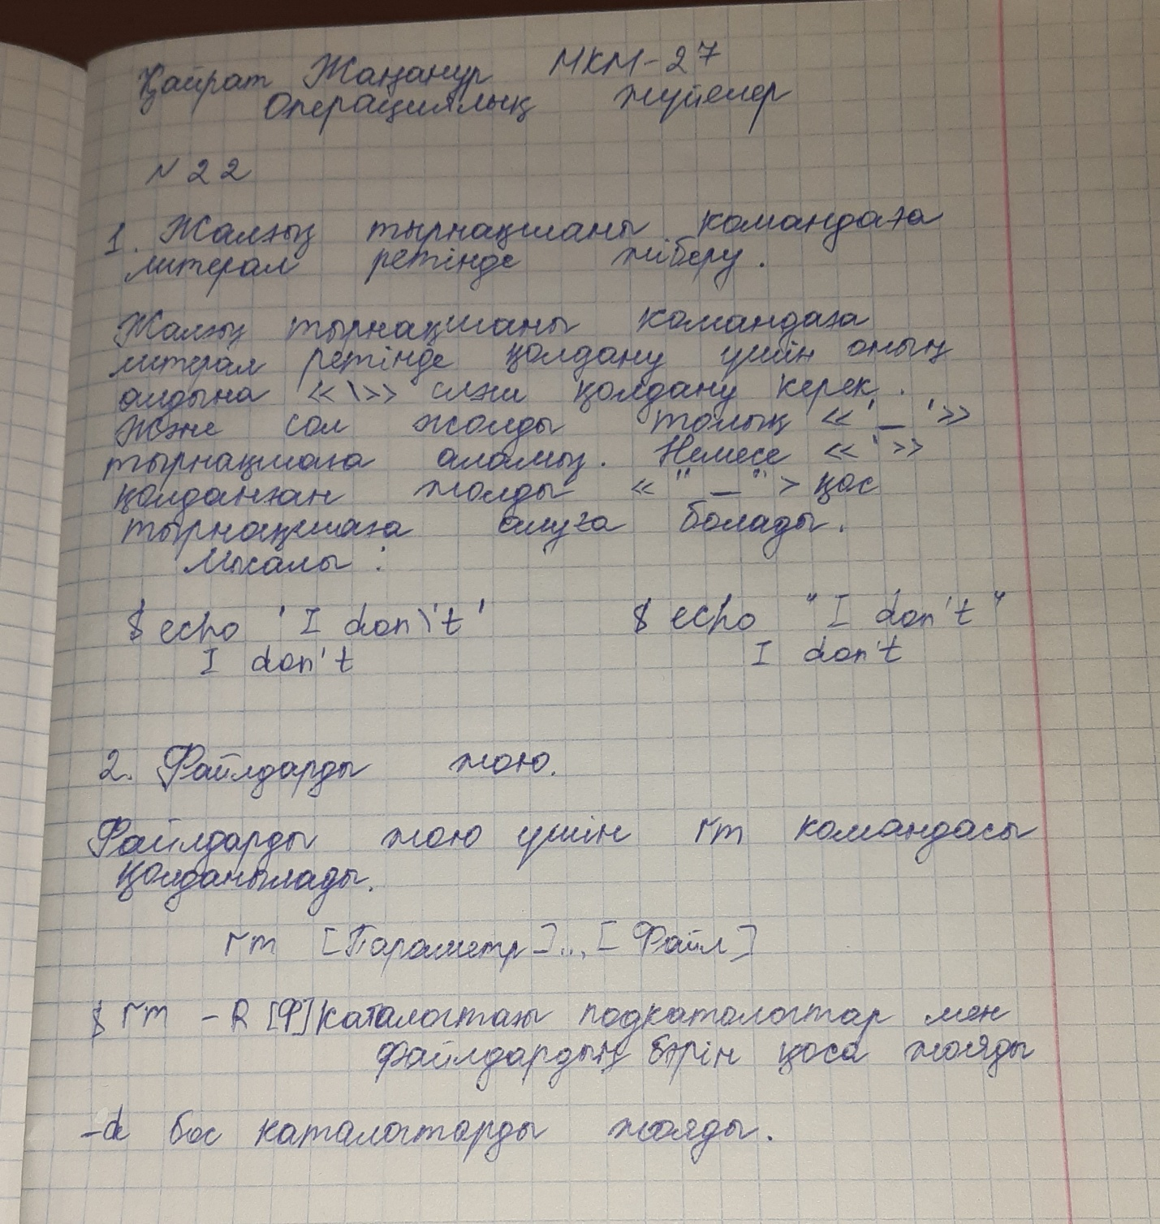

3.Есеп

@echo off

echo %0

set firstex=%1

set secondex=%2

rename \*.%1 \*.%2